February 8, 2019

For Immediate Release:

State Fair Park Kicks Off New Year with Variety of Events

Oklahoma City, OK - The Redland Rendezvous took place at State Fair Park on January 5 and 6. Over 240 volleyball teams, their coaches, families and spectators travelled to the Bennett Event Center from across the country to participate in and watch the tournament. Sixty percent of attendees came from out-of-town for this event. Attendance for the event exceeded 16,000, generating more than $2.78 million worth of direct spending into the Oklahoma City economy.

The OKC Home + Garden Show took place in the Bennett Event Center and the Centennial Building, January 18 through 20. The show exhibited goods and services from dozens of businesses. Attendance brought more than 29,000 visitors to State Fair Park. The event generated more than $2.72 million worth of direct spending into the Oklahoma City economy.

State Fair Park hosted a total of 16 events during the month of January. In addition to the above mentioned, other events included: the 2019 Jr. Open Wrestling Championship, Midwest Arms Collector Gun & Knife Show, Oklahoma Bridal Show, OKC Boat, RV & Tackle Show, OKC Gun Show, 2019 International Finals Rodeo, Oklahoma City Patriot Qualifier Team Roping Event, OKC Gem, Jewelry & Bead Show, Oklahoma Gun Shows, Federal Employee Mobile Food Distribution, 65th Annual OKC Boat, RV and Outdoor Show, Survival Expo & Gun Show, Greater Oklahoma Hunter Jumper Winter Schooling Show, and the OKWA Novice State Championships. In all, there were 107,457 visitors present during January events held at State Fair Park, generating more than $12.08 million in direct spending into the Oklahoma City economy.

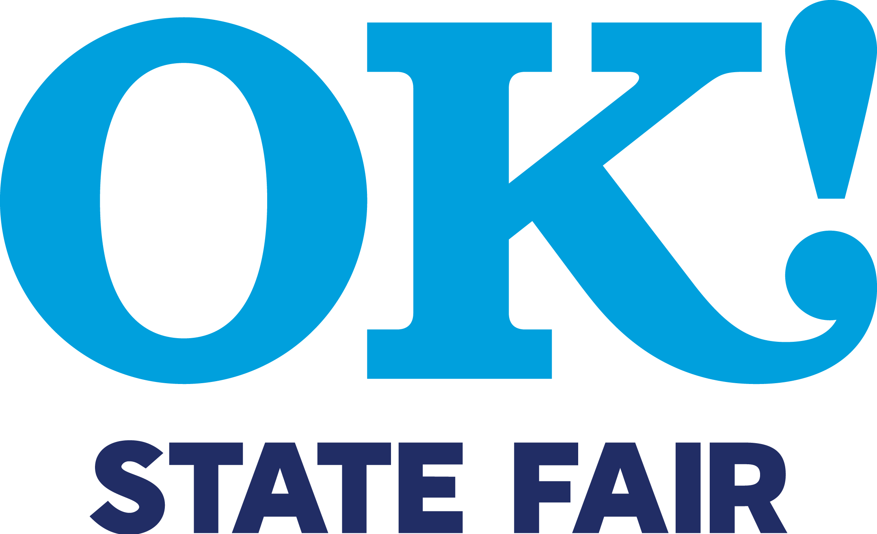 | NEWS RELEASE  OKLAHOMA STATE FAIR, INC.  MEDIA RELATIONS DEPARTMENT  405-948-6700  pressreleases@okstatefair.com  www.okstatefair.com | 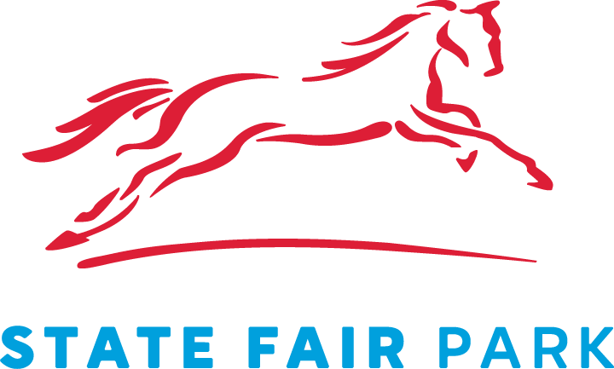

For more information regarding the January events, or any upcoming months, please contact the State Fair Park Office at 405-948-6700. To stay up-to-date on all State Fair Park has to offer, visit www.statefairparkokc.com, like us on Facebook and follow us on Twitter and Instagram.
-30-

Contact: Holly Bottrell at 405-948-6829 or hbottrell@okstatefair.com
Scott Munz at 405-948-6700 or smunz@okstatefair.com

